Hamilton County Department of Education is pleased to provide you with access to current grades and attendance for your student through the Power School Parent Portal. With the Single Sign-On process, parents have the ability to create an account to access all of their children’s information from a SINGLE LOGIN. Parents will be required to create their own user name and password to access their child’s information.

To enroll in parent portal, you will need the access letter from your child’s school with the Access ID and Password for that student. If you have more than one child, you will need this letter for each one as each student has an individual Access ID and Password. Once you create your account, you will be able to access all students attached to it with the one login you create. To create an account:
- Open the internet browser on your computer.
- Type http://powerschool.hcde.org/ in the address bar.
- Click the “Create Account” tab and then the “Create Account” button at the bottom of the page
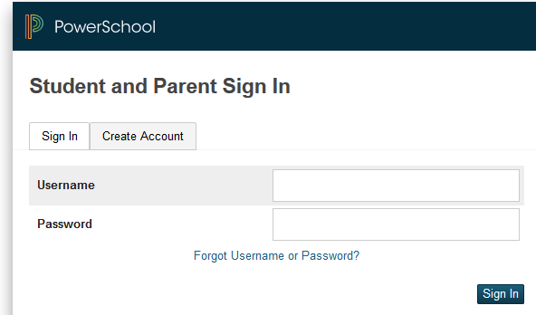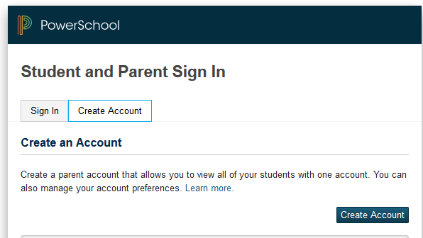

- Complete the fields on the top half of the page: Parent/Guardians first and last name and email address. The email address must be unique. If parents/guardians share the same email address, only one parent access account should be created.
- Enter a username and password. The password needs to be at least 6 characters long.
- You must then link your student(s) to this new account. Enter the student’s name, Access ID and Password (provided on the letter from your student’s school). Select your relationship to the student from the drop-down menu. Click “ENTER” to finish creating your account. NOTE: If you do not have the letter for additional students at this time, they can be added to your account later.
- You should now be at the portal sign-in page. Enter the username and password you chose when you created the account.
ONCE LOGGED IN:
- The “Grades and Attendance” tab will allow you to check assignments and scores by clicking on the blue percentage across from a class.
- “Grade History” will show you the grades your child received in previous grading periods.
- “Teacher Comments” is used to access current teacher comments for your student.
- “School Bulletin” shows current announcements for your school.
- To email the teacher, click the blue teacher’s name link.
If you have linked more than one student to your account, you will see tabs across the top with each student’s name. Click on a name to see the information for that student. To add an additional student, click “Account Preferences” and then the “Students” tab and then the “Add” button.

If you have any questions regarding the use of Power School, please contact the school office.

POWER SCHOOL MOBILE APP

On your mobile device, download PowerSchool Mobile. (Your account must first be created on the parent portal website.)
To Log in: Enter the district code: ZRCD and click “Continue”
Enter your username and password.
If entering the district code does not work, click on “Where’s My District Code?” and choose “Enter Server Address”. Enter: powerschool.hcde.org and click continue. This should take you straight to the login page.

